

***November Good News 2023***

**Our ministry vision for the Virginia Annual Conference is *“to be disciples of Jesus Christ who are lifelong learners, who influence others to serve.”***



**From Pastor Adam**

“A Thanksgiving Song”

*Cantate Domino canticum novum* (Latin)

*Sing to the LORD a new song! (English) – Psalm 96:1; 98:1; 144:9; 149:1*

As I was thinking about this November article I become curious about the origins of the name of the eleventh month of our modern calendar. Where did it begin? Our current calendar of twelve months and 365 days is called the Gregorian Calendar and was put into effect by Pope Gregory in 1582 (in those days the church was in charge of managing time). However, the name “November” got its start in a much earlier Roman calendar which only had ten months, and thus, what was called “November,” (the next to the last month) comes from the Latin word *Novem* which means “nine.” In time, the months of January and February were added to create something that looks like the modern Gregorian calendar, but for a time November was the ninth month. I was struck by how much the word *Novem* (nine) sounds like the Latin word for “new” and “newness” (*Novum*). While this might be pure coincidence, I found the whole idea fascinating. Does November reflect something new? The full flower of Autumn and the change

of the leaves (common in November) is certainly something new. Babies born in November are new. College applications are generally due on November 1, signifying the start of a new season in the life of the young person. When I was in seminary, I sang in the chapel choir and I can still hear myself singing the words of the composer Claudio Monteverdi – “*Cantate Domino canticum novum”* or “Sing to the Lord a new song!” The words were those of the Psalms (96:1; 98:1; 144:9; 149:1). The songs or hymns we love are most often familiar to us. We often know the tunes by heart and have rich memories when we sing them. There is something historical and past tense in our favorite hymns. We are creatures of habit. So the idea of singing a new song to God is a bold sentiment filled with hope, promise, possibility and the awareness that the blessings, faithfulness, and reality of our loving God is ever-new, ever-fresh, and ever-present. Whatever our Thanksgiving Day rituals may be (meals, gatherings, phone calls, etc.), within them there is a rich sense of personal past and connection with our national past (think Pilgrims and Indians). Because God is ever-new and ever-living, we will always have new blessings to celebrate, new mercies

to see, and an awareness that each new day is a gift rich in wonder and possibility. This Thanksgiving, may we sing a new song of the goodness of God and the goodness of life.

God bless you my friends, Adam

Circle News****

The Wesleyan Group …will meet on Monday, November 13, 2023, at 7:00 p.m., at the home of Jane White.

The Merry Marthas Circle will meet at church on Thursday,

November 2nd, at 10:00 am for a “field trip” to the University of Lynchburg’s Claytor Nature Center in Bedford. If the weather is suitable we will eat a picnic lunch there (each bring their own sandwich or salad, I will bring dessert). If rainy or too cold, we will eat at a restaurant in Bedford. We will carpool from church, to be there by 11:00. Anyone is welcome to join us! ~*Judy Robertson*

*Mission Memo*

In the Park View Mission food cart for October we collected 39lbs of food products and 12.5lbs of hygiene items. Thank you for your faithful support for this mission.

In November we will continue to collect items to make side dishes for a holiday meal. Canned vegetables, stuffing mix, instant potatoes, rice, cranberry sauce, and so forth. Keep in mind with the holidays fast approaching the mission is

experiencing an uptick in the number of clients

needing assistance.

~*Linda Jessen & Mission Committee*

**Food Cart..November**

Canned vegetables, stuffing mix, instant potatoes, rice, cranberry sauce, and any other side dish to make a great holiday meal.

*No* ***“baked goods”*** *!* *Place donations in the grocery cart, located in the Commons*.



**The choir** will be singing on Sunday, November 12th, and will be rehearsing

at 10 AM. We will sing familiar hymns so please come join us!

*~Heather Wilson*, Director of Music

***Park View Closet ~ Winter Clothing***

Needed: Park View is now accepting winter clothing. Bring items to church and Linda Jessen will take to the mission. Bring items to church, **Monday—Thursday**, 9:30 a.m. to 3:00 p.m.

**The Mountain View District Palooza** will be held Saturday, **November 11, 2023,** from 9:30 am to 11:30 am at **First UMC in Martinsville** (146 East Main Street, Martinsville). We will start to gather at 9:00 am with light refreshments, then begin our time together with worship in the

sanctuary at 9:30 am. There will be several opportunities for workshops. **Charge Conferences will be held along with our District Conference**. Make plans to attend with at least one representative from your church.



Dear Church Friends,

I want to thank you for all of the pretty birthday cards and thoughtful phone calls I received on my birthday. I had a wonderful day. All of my children were able to be here, so my heart was very happy. I look forward to a year of peace and joy. God loves you all and so do I. ~Blessings, *Pat Short*



**Daylight Saving Time ends** on Sunday, November 5, 2023. Remember to set your clocks BACK one (1) hour before bedtime on Saturday, November 4, 2023.

November

1 Jessica Robbins

5 Christopher Palazzi

8 Karsen Burgess

9 Sylvia Glass

10 Elizabeth Ashworth

11 Casey Fish

13 Pat Moore

14 Kathleen Baker

16 John Martin, Jr.

Maggie Musgrove

17 Christian Barber

Frank Stewart

24 Ann Ruhland

Lee Steward

25 D’Lynn Burgess

Elizabeth Candler

26  Ella Dunn

27  Tad LeFew, III

30 Phillip Yost

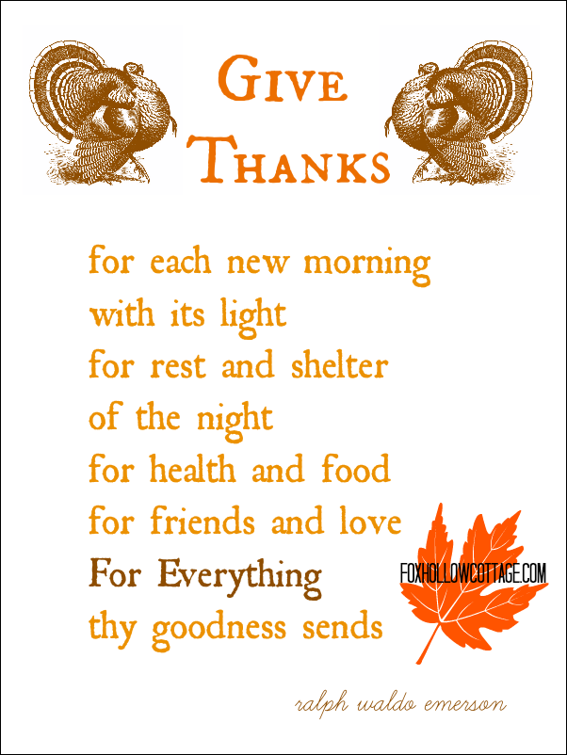



**November 2023**

|  |  |  |  |  |  |  |
| --- | --- | --- | --- | --- | --- | --- |
| ***Sunday*** | ***Monday*** | ***Tuesday*** | ***Wednesday*** | ***Thursday*** | ***Friday*** | ***Saturday*** |
|  | | | **1** | **2**  10:00am Merry Martha's - Field Trip | **3**  10:00am Homeschool | **4**  Homeschool Bee |
| **5 *All Saints Sunday***  ***Daylight Saving Time ends***  9:30am Sunday School  10:30am Worship | **6**  5:00pm CSE (Camp Meadowlark) | **7** | **8** | **9** | **10** ***Church Office Closed***  10:00am Homeschool | **11**  9:30am Mountain View Dist. Palooza-Martinsville, VA |
| **12 *24th Sunday after Pentecost***  9:30am Sunday School  10:00 am Choir  10:30am Worship | **13**  7:00pm Wesleyan Group (Home of Jane White) | **14** | **15** | **16** | **17 *Church Office Closed***  10:00am Homeschool  3:30pm Homeschool Game Evening | **18** |
| **19 *25th Sunday after Pentecost***  9:30am Sunday School  10:30am Worship | **20** | **21** | **22** | **23** ***Church Office Closed*** | **24** ***Church Office Closed*** | **25** |
| **26 *Christ the King Sunday***  9:30am Sunday School  10:30am Worship | **27** | **28** | **29** | **30** |  | |





1 Pat Short

2 Nancy Lee

Emily V.

Fernandez

3 Michael McGlothlin

6 Kirsten Bell

Tim Crist

Dennis Tolley

7 Kenny Busic

Cheryl Powell

9 Owen Stinnette

Jeremey

VandeBogart

11 Landen Glass

12 Camden Mason

14 Wade Ware

16 Burton Brooks

Terry Palazzi

Anne-Elaine Tiller

17 Suzanne

Marshall

Blake Phillips

18 Sharon

Rickmon

19 Connie Yost

20 Erin Ecklund

21 Steven Kinzer

22 C.O. Bell

25 Frankie

Hardwick

28 Jacqueline Busic

Cheryl Thomas

29 Wes Robbins

Ricky Smith

31 Robert Baunach

**2022**

**March 2022**

**Those Who Serve ~ November**

**GREETERS:**

November 5 ~ Mary Walker

November 12 ~ Dan Robertson

November 19 ~ Betty Taylor

November 26 ~ Judy Robertson

**Our Church Financial Picture**

Through the end of August 2023

General Operating Funds:

Needed to meet our 2023 Budget $ 196,989

Needed to meet our budget to date $ 131,326

Actual receipts to date $ 109,652

Shortage to meet budget to date $ 21,674

Actual expenditures to date $ 107,142

Overage to meet expenses to date $ 2,510

Joy In Missions Funds

Our Giving Goal for 2023 $ 9,600

Needed to meet our goal to date $ 6,400

Actual receipts to date $ 7,775

Special Offerings* (not budgeted):

Received to date $ 7,400

Dispersed to date $ 6,890

*Christmas, Easter, Annual Conference,

World Communion, etc.

**2023 Joy In Mission Donations**

To date, the following amounts have

been paid to the missions indicated.

Budget Spent

1. Missionary Covenant Relationship

$1,000 $ 500

2. Park View Mission, Food for Families

$3,000 $1,760

3. Society of St. Andrew $1,000 $ 500

4. Adult Care Center $ 500 $ 0

5. Blue Ridge Area Food Bank $1,000 $ 500

6. Daily Bread $ 500 $ 250

7. Free Clinic $ 500 $ 0

8. Good Neighbor $ 500 $ 0

9. Habitat for Humanity $ 500 $ 250

10. UMCOR-Non-Administrative $ 500 $ 0

11. Undesignated $ 600 $ 0

Thank you for your generosity.

**GOOD NEWS** is

published monthly for members and

friends of Chestnut Hill United

Methodist Church. Send articles to

the church office by the 15th of the

month. (Subject to change).

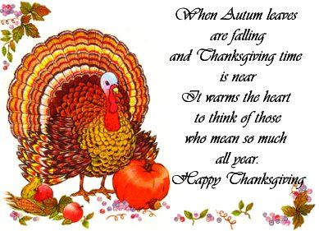





January 2022

**2022**

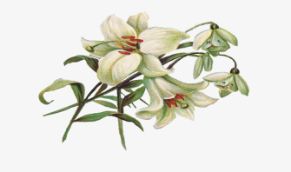

**April 2022**

**April 2022**

**March 2022**



*Chestnut Hill United*

*Methodist Church*

4660 Fort Avenue, Lynchburg, VA 24502

Phone Number: 434-239-8423: FAX: 434-239-7209

E-mail: [chestnuthillumc@comcast.net](mailto:chestnuthillumc@comcast.net)

On the web: www.chestnuthillumc.net

Church Office Hours

**Monday-Thursday~**9:00 am—3:30 pm

**Friday~**9:00 am-1:00 pm



***DIRECTORY OF***

***CHESTNUT HILL UNITED METHODIST CHURCH***

|  |  |  |
| --- | --- | --- |
|  | Sue Haupert-Johnson | Richmond Area Resident Bishop |
|  | Denise Bates | Mountain View District Superintendent |
|  | Adam White | Minister |
|  | Erin Long | Associate Minister |
|  | Monica Campbell | Administrative Assistant |
|  | Heather Wilson | Director of Music Ministry |
|  | Judy Martin | Bookkeeper |
|  | Judy Robertson | Lay Leader |
|  | Elizabeth Nichols | Missionary in Henry County |